UNODC

United Nations Office on Drugs and Crimes

MSMUN 2024

Chair:

Helena Domínguez

Luciana García

Official language:
English

Topic A:

Examining Illicit Financial Activities, Terrorist Funding, and the Seizure of Illegally Acquired Assets

Topic B:

Justice System Reforms For Law Enforcement And Systematic Accountability For Abuses Of Power

Index:

- Welcoming Letter

- General Information
2.1. History/Introduction
2.2. Purpose

3. Topic A: Examining Illicit Financial Activities, Terrorist Funding, and the Seizure of Illegally Acquired Assets

3.1. Historical context
3.2. Current situation
3.3. Previous resolutions
3.4 International response
3.5. Useful sources
3.6. Expectations for debate

4. Topic B: Justice System Reforms For Law Enforcement And Systematic Accountability For Abuses Of Power

4.1. Historical context
4.2. Current situation
4.3. Previous resolutions
4.4 International response
4.5. Useful sources
4.6. Expectations for debate

5. QARMAS

5.1. Topic A
5.2. Topic B

6. Delegation list

7. References

- Letter from the Chair
Dear delegates,
It is with great honor that we welcome you to this year’s MSMUN UNODC committee. We are more than pleased to have the opportunity to preside over the United Nations Office on Drugs and Crimes. This year the topics we will be debating are the examination of illicit financial activities, terrorist funding, the seizure of illegally acquired assets, and justice system reforms for law enforcement and systematic accountability for abuses of power. Both of these issues play a fundamental part in our community and must be discussed.
As your presidents, we expect compromise before and during the model; previous research of both topics, active participation during the debate, and enjoying the model overall.
We invite you to take this as an opportunity to expand your knowledge, learn, improve your debating skills, increase your critical thinking, and gain enough confidence to be able to defend an ideology. Acquire qualities such as leadership, diplomacy, and strategic thinking for additional growth. But also to meet new people and make friends. We hope that during the days of the model, the debate flows well and that both topics can end in sustainable and creative solutions.
We further remind you not to hesitate to reach out for our help, as we will always try to help you as soon as we get the chance, and are at our disposal to answer any concerns you may have.
Without further ado, we want to thank you for your participation in the model, to help us Make the Impossible Possible.
Welcome to UNODC MSMUN 2024!
Sincerely,
Helena Domínguez Posada +57 305 402 7655
Luciana García Ochoa +57 317 637 8011
- Introduction to the Committee
2.1. Historical Context
It was established in 1997, by the UN Secretary-General as the result of the union
between the United Nations International Drug Control Programme and the United Nations Centre for International Crime Prevention, to help the organization deal with interconnected issues of drug control, international terrorism, and crime control. (UNODC, 2023).
The UNODC plays a significant role in fulfilling its responsibilities when supporting State Parties in the following International Treaties:
1. 1961 Convention on Narcotic Drugs
2. 1971 Convention on Psychotropic Substances
3. 1988 Convention against the Illicit Traffic in Narcotic Drugs and Psychotropic;
Serving as the official record of the United Nation’s norms and guidelines for crime prevention and criminal justice.
In the beginning, it was established with the sole purpose of controlling narcotics and their possible uses, as well as combating terrorist attacks and preventing any criminal activity through the employment of and creation of coalitions and new legal frameworks. (UNODC, 2023).

2.2. Functions and Objectives
The United Nations Office on Drugs and Crimes was created as a way to protect
worldwide citizen’s security.
This entails dismantling international networks of criminal organizations, combating drug usage and trafficking, and establishing protection programs as a response to international terrorism.
As a result, it allows its member countries to increase their capability for security, including legal system enhancements via reforms, checking compliance with international law, and seeking the promotion of people’s rights.
Since its establishment, the UNODC has recognized the struggle and difficulty on the scale of its issues, however; it makes great efforts to take action over them, foremost working on a human rights-based system.

According to the Kingdom of Netherlands Permanent Representations, the activities of UNODC are based on three pillars:
i) research and analysis (evidence-based policies);
ii) establishment of international norms and standards (UN Conventions);
iii) capacity-building through technical assistance. (2023).

Apart from that, its thematic areas are
- Drug prevention, treatment, and care
- Crime prevention and criminal justice
- HIV/AIDS
- Drug trafficking
- Corruption
- Human trafficking and migrant smuggling
- Money-laundering
- Piracy
- Terrorism prevention
- Ensuring the visibility and validity of law across the world’s nations through reforms

- Topic A: Examining Illicit Financial Activities, Terrorist Funding, and the Seizure of Illegally Acquired Assets
3.1. Historical Context
Illicit financial flows consist of cross-border money movement that is illegal in its source, transfer, or use; smuggling is an example of this.
Illicit financial flow covers many sectors of impact such as social, economic, and political challenges. And is recognized as one of the greatest obstacles to a sustainable future; efforts to battle this issue need to be led in the private sector, as there are many advisors such as lawyers, accountants, bankers, and real estate agents as a way to disrupt and prevent.
Effective anti-money laundering and combating the financing of terrorism (AML/CFT) courses of action are fundamental for the integrity and stability of international economies. Terrorist funding can have an impact as it counts as “hot money” resulting from inflows and outflows, and governance weaknesses. Over the past 20 years, the Fund has been aiming to help solutions that can finance AML/CFT policies, which stop criminals from engaging and proceeding with criminal transactions and reaching the origins of illegal activity (IMF, n.d.).
Seized or frozen property deprives criminals of their unlawfully acquired assets. This is a crucial step when battling against organized crime, as it also serves as a deterrent to the laundering and reinvestment (reutilization) of criminal proceeds in illicit commercial business activities. On December 21, 2016, the European Commission made the idea for mutual recognition of confiscation first known. Which was formally adopted by the European Parliament and Council on November 14, 2018, and came into effect on December 19, 2020, replacing 2003 to 2006 framework decisions regarding the topic, as these were outdated to the frameworks established for the European Union. Nonetheless, these still operate for Denmark and Ireland (European Commission, n.d.).

3.2. Current Situation
Criminal activity is nowadays an important part of the terrorist economy, with drug trafficking being the main and largest activity that funds terrorism, not excluding other substantial financial sources such as racketeering, precious stones traffic, abductions (with ransom), and trafficking human beings, which criminal organizations enforce, some of these being, the FLNC, Khmer Rouge, rebel groups in Sierra Leone and Angola and paramilitary groups in Colombia.
These issues of IFFs and Terrorist Funding are at the foreground of the international community, as organized crime brings forth considerable amounts of illicit profits globally:
Countries that are thought to have availability of crime-related IFF estimates (see Figure 1) that relate to inflows and outflows from illicit income generation and inflows and outflows from illicit income management have been provided with the assistance of the UNODC to support the development of IFF measurement which will hopefully become a statistical framework.

Figure 1
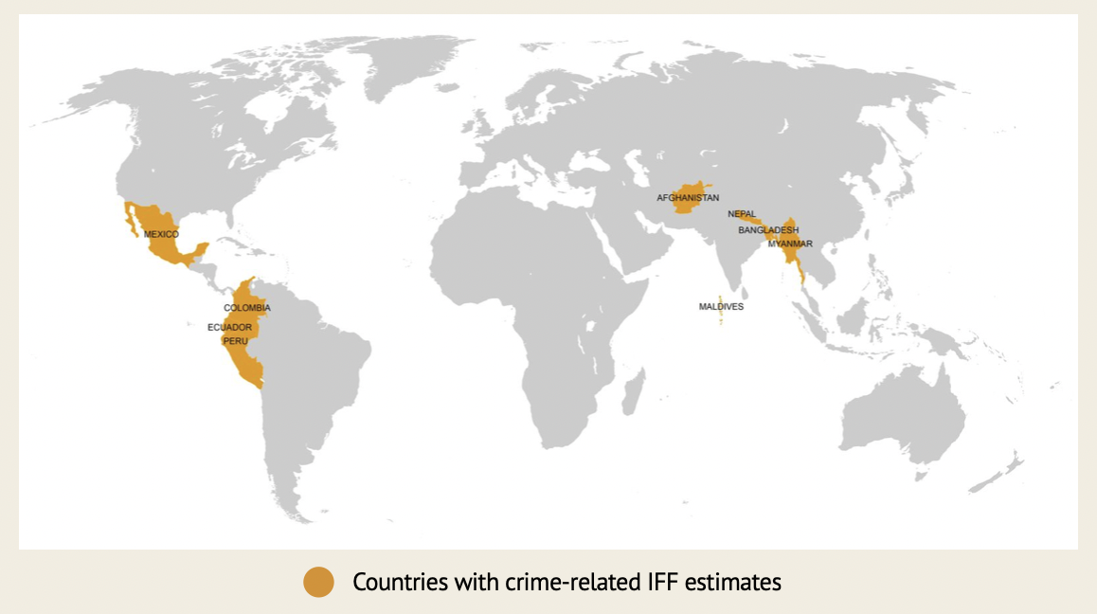
Source: UNODC Research
In Latin America, four countries (Ecuador, Mexico, Peru, and Colombia) were chosen for studies regarding the IFF measurement process, by collecting information from illegal drug markets, migrant smuggling, and other exploitation-type activities:
- Ecuador: Due to its geographic location, transnational crime organizations and migrants often seek to operate in Ecuador, because it is a transit country that counts with proximity to cocaine producers such as Colombia. The outward IFFs estimated to result from the smuggling of migrants from 2016 to 2018, varies from approximately USD 19 million in 2016 to USD 10.8 million in 2018.
- Mexico: the United States is where they mainly operate, It is estimated more than 800 thousand smuggled migrants each year from Mexico to the United States. Simultaneously, the drug business with opiates, cocaine, and methamphetamine, stipulates a vast majority of the illicit market for drugs in the continent; see Figures 1 and 2 for the statistics gathered in the conducted pilot study from the UNODC.
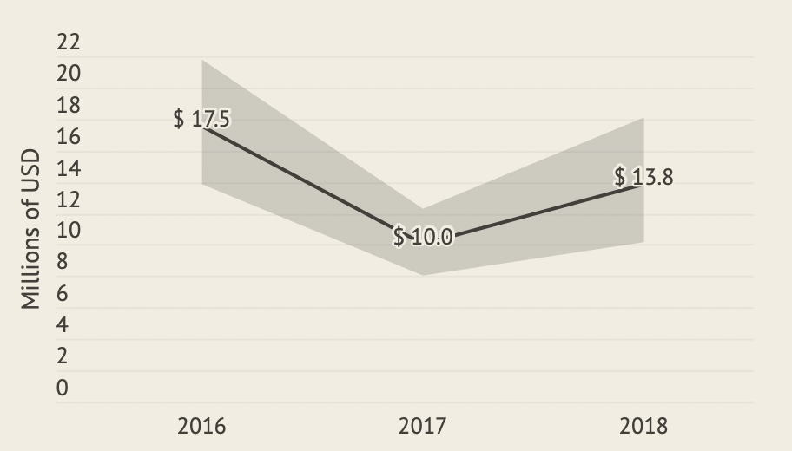
Figure 2
Outward IFFs resulting from migrant smuggling in Mexico from 2016-2018

Figure 3
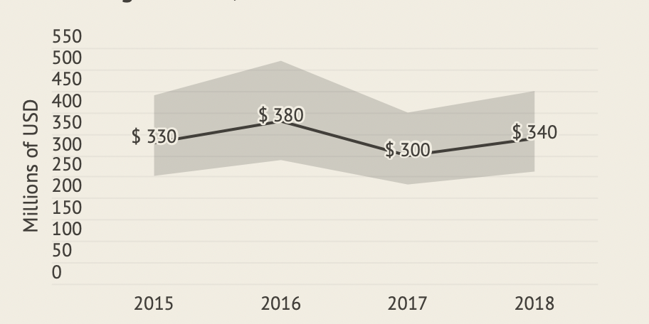
Outward IFFs resulting from cocaine trafficking in Mexico from 2015-2018

- Peru: is the world's second-largest supplier of cocaine, with traffickers involved in both extra-continental export (mainly to European organizations) and cocaine trafficking in South American countries.
- Colombia: on a global level it accounts for the largest share of cocaine production and cultivation, registering the following outward and inward IFFs,
inward IFFs related to cocaine trafficking out of Colombia were estimated in a range of USD$1.2-8.6 billion in average per year from 2015-2019, while outward IFFs resulting from cocaine trafficking were estimated at USD$227 million in average (USD$197-267 million) annually during the same period (UNODC Research, 2023).
As a result, drug trafficking has significant importance regarding IFFs, which are determined by the supply chain location, meaning that each country has a different type of illicit financial flows depending on its focus: Countries that are keen on production have outward IFFs that mainly reflect the capital cost of supplying the goods needed for the production process, and tend to be outweighed by the inward IFFs, as can be seen in the quote above. Additionally, transit countries tend to have the same effect, where inward illicit flows surpass outward flows, primarily due to the importation and exportation costs.

Nevertheless, drug trafficking is certainly not the only important issue on this topic. Concerning terrorist financing, a main channel is the practice of collecting funds from the diaspora, in some cases these being compatriots in exile or expatriates for economic reasons; for instance, “The IRA has drawn a large part of its revenues from the Irish community in the United States, and this has also been done by the GIA in Algeria, by the Al-Qaeda, Sri Lankan rebels, Armenian terrorists, to cite just a few” (IMF Legal Department). Simultaneously, a broad approach to comprehend and identify the potential links of financing activities towards terrorists is being conducted: by focusing beyond the movement of funds, and to identify connections between contributions and partnerships, even if they do not contain transactions per se, thus achieving the objective of preventing and detecting any support or involvement with terrorism. Bearing this in mind, some forms of participation in terrorist activities include (among others):
- engaging in, or being responsible for providing support, the commission, preparation, or instigation of an act of terrorism,
- facilitating, promoting, or encouraging terrorism,
- providing or receiving terrorism training,
- recruiting for terrorism, soliciting funds or otherwise procuring funds, organizing, providing support for, or otherwise facilitating the traveling costs of foreign terrorist fighters or other terrorists,
- being responsible for a coercive action against a person on behalf of or in the name of, a terrorist entity (Jersey Financial Services Commission, 2022).
3.3. Previous Resolutions
Many strategies have been taken into practice, showing slight impacts on economic and social areas. Nonetheless, some strategies that have been implemented in different countries are:
- Establishing up-to-date strategies
- Determining the dangers, scope, and nature of IFFs, and creating public awareness
- Ponder about the surrounding conditions that encourage the growth of IFFs
- Promote consistency both within national and international magnitude normative frameworks (Vertical coherence)
- Reflect on substantial connections between the social, economic, and environmental domains (Horizontal coherence)
- Facilitate collaborations and recognize possible compromises among industries to tackle money laundering (OECD, n.d.).
Figure 4 shows the main principles when combating IFFs and money laundering, and shows industries or main characters that act as gatekeepers when handling this issue.
Figure 4
5 Practices to Prevent and Disrupt Illicit Financial Flows | Stolen Asset Recovery Initiative (StAR)
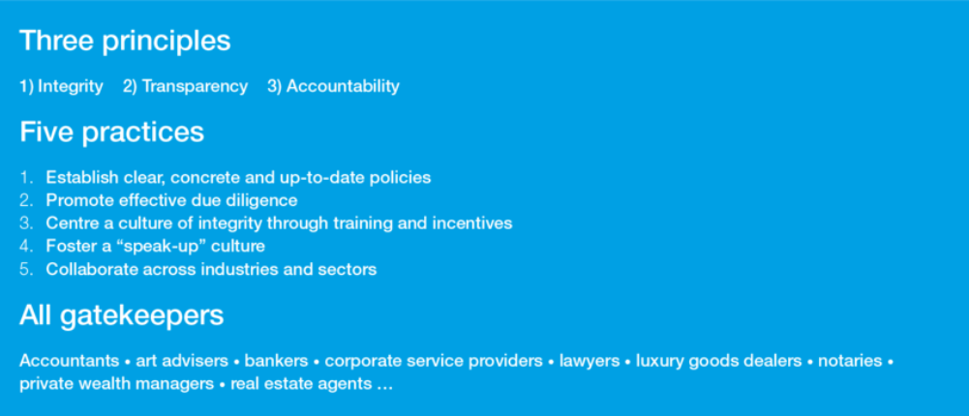
Source: Stolen Assets Recovery Initiative

3.4. International Response
By recovering illicitly obtained assets, organized crime, and illicit financial flows can be confronted as it privates the financial gains from criminals. These assets will be liquidated and reinvested in social welfare and priority development needs, thus the dangerous impacts of illicit financial funds will be mitigated.
In Europe, a legal framework that encloses tracing, identification, and confiscation of assets that were illegally acquired is one of the continents’ main milestones: “The ability to freeze and confiscate assets depends directly on the capacity to effectively trace and identify them. Council Decision 2007/845/JHA 7 obliges Member States to set up or designate national Asset Recovery Offices to ensure the fastest possible EU-wide tracing of illicit assets.” (European Commission), as well as the process that it follows through with the following phases:
- Recognizing and tracking illegally acquired assets.
- Restricting and the seizure of assets, with the possibility of a subsequent confiscation.
- To maintain asset value, the management of those frozen and seized assets
- Expropriation of illegal assets.
- Reusing the assets for public or social purposes, by disposing of these.

Simultaneously, international organizations have aimed at successfully preventing criminal organizations from profiting due to crime,
The United Nations Convention against Transnational Organized Crime, together with the work of the Financial Action Task Force and other initiatives such as the Stolen Asset Recovery (StAR) Initiative,19 provides broad guidelines on how to respond to the movement of criminal profits. Essentially, they illustrate how States should establish the tools to undertake organized crime investigations, prosecutions, and confiscation applications that target the instrumentalities and proceeds of crime. (UNODC, 2012)

3.5. Useful Sources
United Nations Office on Drugs and Crimes. (2012). Manual on International Cooperation for the Purposes of Confiscation of Proceeds of Crime. United Nations Office on Drugs and Crime. https://www.unodc.org/documents/organized-crime/Publications/Confiscation_Manual_Ebook_E.pdf
Ulbrich, C. (2021, June 2). 5 practices to prevent and disrupt illicit financial flows | Stolen Asset Recovery Initiative (StAR). Stolen Asset Recovery Initiative. https://star.worldbank.org/blog/5-practices-prevent-and-disrupt-illicit-financial-flows
International Monetary Fund. (n.d.). Anti-Money Laundering and Combating the
Financing of Terrorism (AML/CFT). International Monetary Fund. https://www.imf.org/en/Topics/Financial-Integrity/amlcft

3.6. Expectations for the debate
On this topic, we expect the focus on international response measures, anticipating the discussions regarding already existing legal frameworks and guidelines, and debating on the roles that different organizations such as financial institutions may have in preventing IFFs and terrorist funding. Human rights, preventive measures, asset recovery, and different challenges that come with these important aspects may bring into the debate different strategies, positions, and concerns, that must be addressed. Altogether, a thorough investigation and analysis are expected, especially in those matters that go beyond organizational crime, such as the technological challenges, safeguarding, and the effects this topic has on developing nations and world powers.
- Topic B: Justice System Reforms For Law Enforcement And Systematic Accountability For Abuses Of Power
4.1. Historical context
The role that police must follow through is to protect and defend civilians, yet historically police officers have been recognized for having the freedom to abuse, bribe, accuse incorrectly imprison, and most importantly, be responsible for homicides of citizens with little to no consequences. Race, economic and social status, and most importantly, corruption, play an important part in this abuse of power by the police, as least privileged people are often defenseless against this, with no recourse to defend themselves.
Due to this, police agents are often feared for their reputation, which represents violence and crime against the most vulnerable.
Police brutality dates back to the 1800s and early 1900s with worker strikes against big industries, due to their work conditions and low pay: the police had permission to act violently against those citizens who challenged industries as an oppression measure for these labor strikes that were seen worldwide. This brought on many impacts to inhabitants, as law enforcement officers lack consequences for their actions.
In the 21st century, global knowledge of law enforcement officers' brutality was achieved, mainly due to the mass reproduction in media of videos implicating police officers, which led to a deeper investigation at an international level regarding this topic.
Racial, religious, and other minorities are also stopped more often by police in much of Europe, despite generally lower crime rates among these groups. France has long struggled with rampant police targeting and abuse of Black and Arab people, which has at times sparked mass protests. [...] Frequent deaths of indigenous Australians in police custody and prison have fueled outrage for decades. Human rights activists have accused police in several OECD countries—including Greece, Italy, and North Macedonia—of arbitrarily detaining, torturing, or otherwise abusing refugees and migrants. (Council on Foreign Relations, 2022)
4.2. Current situation
Currently, cases of police brutality and abuses of power can be reported in different
nations, alarming governmental entities. An example of recent police brutality is the famous case of George Floyd which took place in May 2020 in the United States causing global protests, not only raising awareness over force misconduct but also as a sign of discrimination that takes place up to a global magnitude. After being elected, Biden reported throughout the White House that all criminal justice systems must respect citizens’ rights and dignity, to guarantee fair and impartial justice for everyone. And reaffirms that public safety depends on citizens’ trust (The White House, 2022). Nonetheless, after many events, it has been shown that people do not seem to trust governmental entities as they feel unsafe in their countries, and do not think that proper actions have been implemented for it to feel otherwise.
Worldwide the accountability for abuses of power shows that not even legal stipulations are enough to prevent the over and misuse of power that has been given to forced entities, that is why it is completely pertinent for agencies to set professional standards, as the day-to-day presented situations agitate police officers to use their power and go against the law (UNODC, 2019).
Throughout history, these crimes have resulted from deceit and dishonesty, however; the development of technology and the advances in society have made the environment more favorable for them to take place (B Autcher, et. al., n.d.).

4.3. Previous resolutions
To address international police brutality and abuses of power, legal and social measures must be sought. Some resolutions, conventions, and strategies that have been established are:
- Convention on the Elimination of All Forms of Racial Discrimination (CERD).
- Office of the United Nations High Commissioner for Human Rights (OHCHR) International Human Rights Standards for Law Enforcement
- European Convention on Human Rights
- UN Code of Conduct for Law Enforcement Officials

4.4 International response
Countries like the United States have identified the prevention of white-collar
crimes as one (1) of its main four areas of priority. The Department of Justice, the Federal Regulatory agencies, and expanded State and local agencies have made great efforts and contributions.
Training programs have been taking courses to perform further research into these types of crimes. Spending limited monetary resources, to able to keep their focus on enhancing law enforcement (B Autcher, et. al., n.d.).
After deep investigation, it seems that abuses of power are the ones that hold responsibility for populism, autocracy, and the slow deterioration of fundamental rights. Both Europe and the United States are facing extreme cases of poverty and low demand for opportunities, which could be partially blamed on globalization. This is shown throughout undone jobs coming from different entities or labor areas, and people who live without access to basic needs such as healthcare, food, and/or water (Harley, 2023).
Although the European Union is known as one of the least corrupt regions in the world, this one has also taken preventive measures to tackle abuses of power. An example is that on May 3rd, 2023, the Commission adopted a new anti-corruption plan. This one proposes a new directive that uses criminal law to battle corruption. It is designed with a modern approach and harmonizes the European Union’s regulations on their definitions and appliances when it consists of criminal offenses. Prevention is the principal method implemented by the EU, as it is the best way to help support a culture that forbids impunity and corruption.
The plan includes as well a specialized Common Foreign and Security Policy (CFSP) penalties framework to punish acts of corruption globally, as it does for enhancing penalties through the European Union (European Commission, n.d.).

4.5. Useful sources
Amnesty International. (2023, June 8). Police Violence Around the World. Amnesty International USA. https://www.amnestyusa.org/issues/deadly-force-police-accountability-police-violence/
Haynes, D. F. (2023, April 22). Rule of Law Chronicles: Government Abuse of Power. JURIST. https://www.jurist.org/features/2023/04/22/the-rule-of-law-chronicles-government-abuse-of-power/
The Force of the Police An Analysis of Police Violence Based on Experience in the United States and the Imperative to Restore Legitimacy. (2022). https://www.ictj.org/sites/default/files/2023-06/ictj_report_police_brutality_web_0.pdf

4.6. Expectations for debate
Throughout the debate, we expect compromise and participation when it comes to finding relevant solutions, finding ways in which police brutality and abuses of power can be reduced, and what legal parameters can be taken into account when imposing responsibility on all those who infringe the fundamental rights of citizens.
Besides, full commitment is expected; previous research on the topic, for the delegates to master their position and propose new alternatives to help the flow of the debate, and find ways in which the authorities can address the issue, keeping in mind the UDHR (Universal Declaration of Human Rights).
Lastly, we expect delegates to find a way to defend tough positions or gain the capacity to discuss the different political speeches concerning how force entities are conducted by corruption or criminal behaviors.

5. QARMAS
5.1. Topic A
- Are there any national strategies that include measures to combat IFFs?
- Which sectors and non-governmental agencies are required to implement policies to tackle IFFs?
- What could be other formal or informal channels that could be implemented for fostering collaboration and raising awareness across entities battling Illicit Financial Flows?
- Do resources in your country get distributed properly based on risk, within the budget or off the budget, through donors' requests?
- What strategies does your delegation propose as a way to decrease the percentage of the global economy that is based on illegal purchases or illegally acquired assets?
- What sources internally or externally linked to your country are the ones that invest the most in terrorist activities?

5.2. Topic B
- Has your delegation presented any cases of abuses of power) If so, how has your government dealt with them?
- What policies could be standardized globally as a way to penalize abuses of power?
- What is the main source of harassment in your delegation? What actions have been taken to tackle these types of persecution? E.g. Intimidation, discrimination, etc.
- How could the international community intervene? What kind of programs or policies could it implement to handle the situation correctly?
- How can one differentiate between the legitimate exercise of authority and an abuse of power?
- How does the media help when holding people or institutions accountable for misuse of authority?
- How can education and strategies for raising awareness contribute to preventing abuses of power?

6. Delegation list
- The United States of America
- Russian Federation
- French Republic
- People’s Republic of China
- The United Kingdom of Great Britain and Northern Ireland
- The Republic of Colombia
- The United States of Mexico
- Republic of Peru
- The Kingdom of Denmark
- The Kingdom of Spain
- Federal Republic of Germany
- The Republic of India
- The Kingdom of Thailand
- Bolivian Republic of Venezuela
- The Republic of Yemen
- Kingdom of Saudi Arabia
- Republic of Ghana
- Democratic Republic of the Congo
- United Arab Emirates
- The Republic of the Union of Myanmar
- Islamic Republic of Afghanistan
- Federal Republic of Nigeria
- Republic of El Salvador
- The Republic of Guatemala
- The Federative Republic of Brazil

7. References
European Commission. (n.d.). Confiscation and freezing of assets - European Commission. European Commission. https://commission.europa.eu/law/cross-border-cases/judicial-cooperation/types-judicial-cooperation/confiscation-and-freezing-assets_en
International Monetary Fund. (n.d.). Anti-Money Laundering and Combating the Financing of Terrorism (AML/CFT). International Monetary Fund. https://www.imf.org/en/Topics/Financial-Integrity/amlcft
International Monetary Fund. (n.d.). The IMF and the Fight Against Illicit Financial Flows. International Monetary Fund. https://www.imf.org/en/About/Factsheets/Sheets/2023/Fight-against-illicit-financial-flows
OECD. (n.d.). Illicit Financial Flows from Developing Countries: Measuring OECD Responses. OECD. https://www.oecd.org/corruption/illicit_financial_flows_from_developing_countries.pdf
Traverso, G., & Shaw, J. (2021). ILLICIT FINANCIAL FLOWS AND ASSET RECOVERY In The Republic of Armenia. EEAS. https://www.eeas.europa.eu/sites/default/files/illicit_financial_flows_and_asset_recovery_in_the_republic_of_armenia_en.pdf
Ulbrich, C. (2021, June 2). 5 practices to prevent and disrupt illicit financial flows | Stolen Asset Recovery Initiative (StAR). Stolen Asset Recovery Initiative. https://star.worldbank.org/blog/5-practices-prevent-and-disrupt-illicit-financial-flows
United Nations Office on Drugs and Crimes. (2012). Manual on International Cooperation for the Purposes of Confiscation of Proceeds of Crime. United Nations Office on Drugs and Crime. https://www.unodc.org/documents/organized-crime/Publications/Confiscation_Manual_Ebook_E.pdf
Auchter, B., Katz, J., & Graham, M. (n.d.). Crime and the Abuse of Power - Offenses and Offenders Beyond the Reach of Law? Office of Justice Programs. https://www.ojp.gov/ncjrs/virtual-library/abstracts/crime-and-abuse-power-offenses-and-offenders-beyond-reach-law#1-0
European Commission. (n.d.). Corruption - European Commission. Migration and Home Affairs. https://home-affairs.ec.europa.eu/policies/internal-security/corruption_en
Harley, D. (2023, March 28). Resisting the Abuse of Political Power. The Foreign Policy Centre. https://fpc.org.uk/resisting-the-abuse-of-political-power/
UNODC. (2019, July). Crime Prevention & Criminal Justice Module 5 Key Issues: 2. Key mechanisms and actors in police accountability and oversight. UNODC. https://www.unodc.org/e4j/en/crime-prevention-criminal-justice/module-5/key-issues/2--key-mechanisms-and-actors-in-police-accountability-and-oversight.html
Cheatham, A., & Maizland, L. (2020, July 30). What Are Police Like in Other Countries? Council on Foreign Relations. https://www.cfr.org/backgrounder/how-police-compare-different-democracies
Cooper, H. L. F. (2015). War on Drugs Policing and Police Brutality. Substance Use & Misuse, 50(8-9), 1188–1194. https://doi.org/10.3109/10826084.2015.1007669
Police Abuse of Power in Kenya | IJM. (n.d.). IJM USA. https://www.ijm.org/our-work/police-abuse-power
Riera, M. (2020, July 20). UN Condemns Systemic Racism, Police Violence. Human Rights Watch. https://www.hrw.org/news/2020/07/20/un-condemns-systemic-racism-police-violence-0
The Force of the Police An Analysis of Police Violence Based on Experience in the United States and the Imperative to Restore Legitimacy. (2022). https://www.ictj.org/sites/default/files/2023-06/ictj_report_police_brutality_web_0.pdf
The White House. (2022, May 25). Executive Order on Advancing Effective, Accountable Policing and Criminal Justice Practices to Enhance Public Trust and Public Safety. The White House. https://www.whitehouse.gov/briefing-room/presidential-actions/2022/05/25/executive-order-on-advancing-effective-accountable-policing-and-criminal-justice-practices-to-enhance-public-trust-and-public-safety/

“engaging in a pattern of illegal scheming and activity for profit. A “racket” is a fraudulent and often illegal activity that is often carried out by means of extortion or intimidation” (Encyclopaedia Britannica)
dispersion or spread of a people from their original homeland. (Oxford Language)
if you wish to go deeper into the project, look for the UNODC "Developing indicator on illicit financial flows and monitoring them in Latin America"

