**UNODC**

**United Nations Office on Drugs and Crimes**

**MSMUN 2023**

**Chair:**

Helena Domínguez Posada

Andrea Botero Herrera

**Official language:**

English

**Topic:**

***Examining Cross-Border Irregular Migration from West Africa to the Maghreb and the European Union***

***Index:***

1. **Letter from the Chair**
2. **Introduction to the Committee**

2.1. History

2.2. Functions and Objectives

1. **Topic A: Examining Cross-Border Irregular Migration from West Africa to the Maghreb and the European Union**

3.1. Historical Context

3.2. Current Situation

3.3. Previous Resolutions

3.4. International Response

3.5. Useful Sources

3.6. Expectations for the debate

1. **QARMAS**
2. **References**
3. **Letter from the Chair**

Esteemed delegates,

It is an honor for us to be part of the Marymount School Model United Nations and ~~to~~ have the privilege of chairing the United Nations Office on Drugs and Crimes, UNODC.

This year the topic that we will be discussing is "Examining Cross-Border Irregular Migration from West Africa to the Maghreb and the European Union."

We expect you to engage in this discussion thoughtfully and look for solutions that are pertinent to society and the security of the global community because this is such a significant issue for the international community.

We ask you to have expanded research beforehand and ~~to~~ participate actively throughout the sessions. Likewise, take this as an opportunity to develop self-confidence, leadership, diplomacy, and learn about the world’s current situation.

Finally, remember that we are always available to answer your questions, so please do not hesitate to contact us. We thank you for your participation and compromise!

Without further ado, welcome to UNODC.

Helena Domínguez Posada

+57 305 4027655

Andrea Botero Herrera

+57 317 3688339

**UNODC Presidents**

1. **Introduction to the Committee**

**2.1. Historical Context**

It was established in 1997, by the UN Secretary-General as the result of the union

between the United Nations International Drug Control Programme and the United Nations Centre for International Crime Prevention, in order to help the organization deal with interconnected issues of drug control, international terrorism, and crime control. (UNODC, 2023).

The UNODC plays a significant role in fulfilling its responsibilities when supporting State Parties in the following International Treaties:

1. 1961 Convention on Narcotic Drugs

2. 1971 Convention on Psychotropic Substances

3. 1988 Convention against the Illicit Traffic in Narcotic Drugs and Psychotropic;

Serving as the official record of the United Nation’s norms and guidelines for crime prevention and criminal justice.

In the beginning, it was established with the sole purpose of controlling narcotics and their possible uses, as well as combating terrorist attacks and preventing any criminal activity through the employment ~~of~~ and creation of coalitions and new legal frameworks. (UNODC, 2023).

**2.2. Functions and Objectives**

The United Nations Office on Drugs and Crimes was created as a way to protect worldwide citizen’s security.

This entails dismantling international networks of criminal organizations, combating drug usage and trafficking, and establishing protection programs as a response to international terrorism, allowing its member countries to increase their capability for security, including legal system enhancements via reforms, checking compliance with international law, and seeking the promotion of people’s rights.

Since its establishment, the UNODC has recognized the struggle and difficulty on the scale of its issues, however; it makes great efforts to take action over them, foremost working on a human rights-based system.

According to the Kingdom of Netherlands Permanent Representations, the activities of UNODC are based on three pillars:

i) research and analysis (evidence–based policies);

ii) establishment of international norms and standards (UN Conventions);

iii) capacity-building through technical assistance. (2023).

Apart from that, its thematic areas are:

* Drug prevention, treatment, and care
* Crime prevention and criminal justice
* HIV/AIDS
* Drug trafficking
* Corruption
* Human trafficking and migrant smuggling
* Money-laundering
* Piracy
* Terrorism prevention
* Ensuring the visibility and validity of law across the world’s nations through reforms

1. **Topic A: Examining Cross-Border Irregular Migration from West Africa to the Maghreb and the European Union**

**3.1. Historical Context**

Southern Europe is well-acquainted with the issue of irregular migration originating from key Maghreb countries like Algeria, Morocco, and Tunisia. Since the early 1990s, thousands of North Africans have made attempts to cross the Mediterranean in order to reach Spain and Italy each year. However, recent migration crises have revealed a shift, with an increasing number of sub-Saharan Africans migrating to Libya, Algeria, Tunisia, and Morocco. These regions are often used as transit points to Europe, while some individuals choose to remain in the Maghreb region (de Hass, 2008a).

There is a growing influx of desperate Africans fleeing poverty and conflict in their home countries, attempting to enter Europe through illegal means. This narrative is predominantly presented by the media and is prevalent in public discussions. Striking visuals of African migrants scaling tall border fences between the Spanish enclaves of Ceuta and Melilla on Morocco's Mediterranean coast in 2005, regular attempts to cross the Mediterranean using small fishing boats, and the large arrival of African boat migrants on the Canary Islands in 2006 contribute to the perception of escalating migration pressure from Africa on Europe's southwestern borders (de Hass, 2008a).

In recent years, this issue has gained significant attention on the policy agendas of the EU and its member states. Since the 1990s, European nations have primarily responded to persistent irregular immigration by intensifying border controls. This approach involves deploying semi-military and military forces and equipment to deter sea migration. For instance, border fences were erected in Ceuta and Melilla by the year 2000 when groups of immigrants attempted to force their way in. Spain has been making efforts over the past decade to fortify its borders, implementing measures such as erecting fences, installing early warning radar systems like SIVE (Integrated System of External Vigilance) at the Strait of Gibraltar, and extending these measures to the Canary Islands (de Hass, 2008a).

EU countries have also sought to externalize border controls by transforming the Maghreb countries into a "buffer zone" to alleviate migratory pressures on Europe's southern border. They have achieved this by pressuring specific North African nations to crack down on irregular migration, toughening immigration laws, readmitting irregular sub-Saharan migrants from Europe, and expelling them from their own national territories (de Hass, 2008a).

North African countries have signed readmission agreements with several European countries, often receiving development aid and financial support for (joint) border controls in return. Italy and Spain have recently entered similar agreements with sub-Saharan countries in response to the surge in trans-Mediterranean migration. Spain, Morocco, Italy, and Libya have initiated joint naval patrols and readmission of migrants in exchange for aid since 2000. Frontex, the new EU external border control agency, has also supported patrolling migration routes between certain African countries and European territories (de Haas, 2008a).

Common portrayals of this migration depict it as "new," "growing," and "massive." Media coverage and popular narratives often paint an apocalyptic picture of a "wave" or "exodus" of "desperate" Africans seeking refuge in Europe due to poverty and war, packed in dilapidated ships. There is a widely held belief that millions of sub-Saharan Africans are waiting in North Africa to cross into Europe, fueling fears of an imminent invasion. These migrants are typically seen as economic migrants, although they might present themselves as refugees (de Hass, 2008a).

However, these perceptions lack a strong empirical basis for two main reasons. Firstly, there needs to be more thorough empirical research on this issue. Secondly, the burgeoning body of empirical literature, pioneered mainly by Francophone researchers, is often disregarded. This study aims to enhance understanding of irregular West African migration to North Africa and Europe by analyzing available data from official statistics and emerging policy and research literature. Additionally, it aims to evaluate how policies aiming to curb trans-Saharan and trans-Mediterranean migration have influenced migration patterns (de Hass, 2008a).

**3.2. Current Situation**

The current state of cross-border irregular migration from West Africa to the Maghreb and the European Union presents a multifaceted and challenging situation. Over recent years, there has been a notable surge in the number of individuals embarking on this journey, driven by a combination of factors. Economic and political crises in West Africa, along with perceived opportunities in the Maghreb and the European Union, contribute to this phenomenon (*Migration Flows on the Western Routes*, 2023).

Traversing from West Africa to the Maghreb and the European Union proves to be perilous and fraught with danger. Many migrants undertake the treacherous journey through the Sahara Desert, facing risks of dehydration, starvation, and violence. Additionally, they are vulnerable to exploitation and abuse at the hands of smugglers and traffickers. Upon arrival in the Maghreb or the European Union, migrants encounter substantial challenges, including discrimination, xenophobia, and limited access to essential services (*Migration Flows on the Western Routes*, 2023).

The International Organization for Migration (IOM) reported that in 2022, over 100,000 irregular migrants arrived in Europe via sea, with a majority originating from West Africa. Tragically, the IOM estimates that over 3,000 migrants lost their lives or went missing in the Mediterranean Sea during the same year. The European Union has implemented various measures to tackle irregular migration from West Africa, such as augmenting border security and engaging in cooperation with transit nations. However, these actions have faced criticism for their perceived ineffectiveness and for resulting in human rights violations (*Migration Flows on the Western Routes*, 2023).

The IOM advocates for a more compassionate and comprehensive approach to address irregular migration from West Africa. This includes addressing the root causes of migration, establishing safe and legal migration pathways, and ensuring the protection of migrants' rights. Notably, irregular migrants from West Africa encounter numerous challenges, such as exploitation and abuse by smugglers and traffickers, dangerous travel conditions through the Sahara Desert and the Mediterranean Sea, as well as discrimination and xenophobia upon reaching their destinations (*Migration Flows on the Western Routes*, 2023).

Crucially, the overwhelming majority of irregular migrants from West Africa are fleeing poverty and violence in their home countries, seeking improved prospects for themselves and their families. It is essential to approach their circumstances with empathy and respect, recognizing their aspirations for a better life (*Migration Flows on the Western Routes*, 2023).

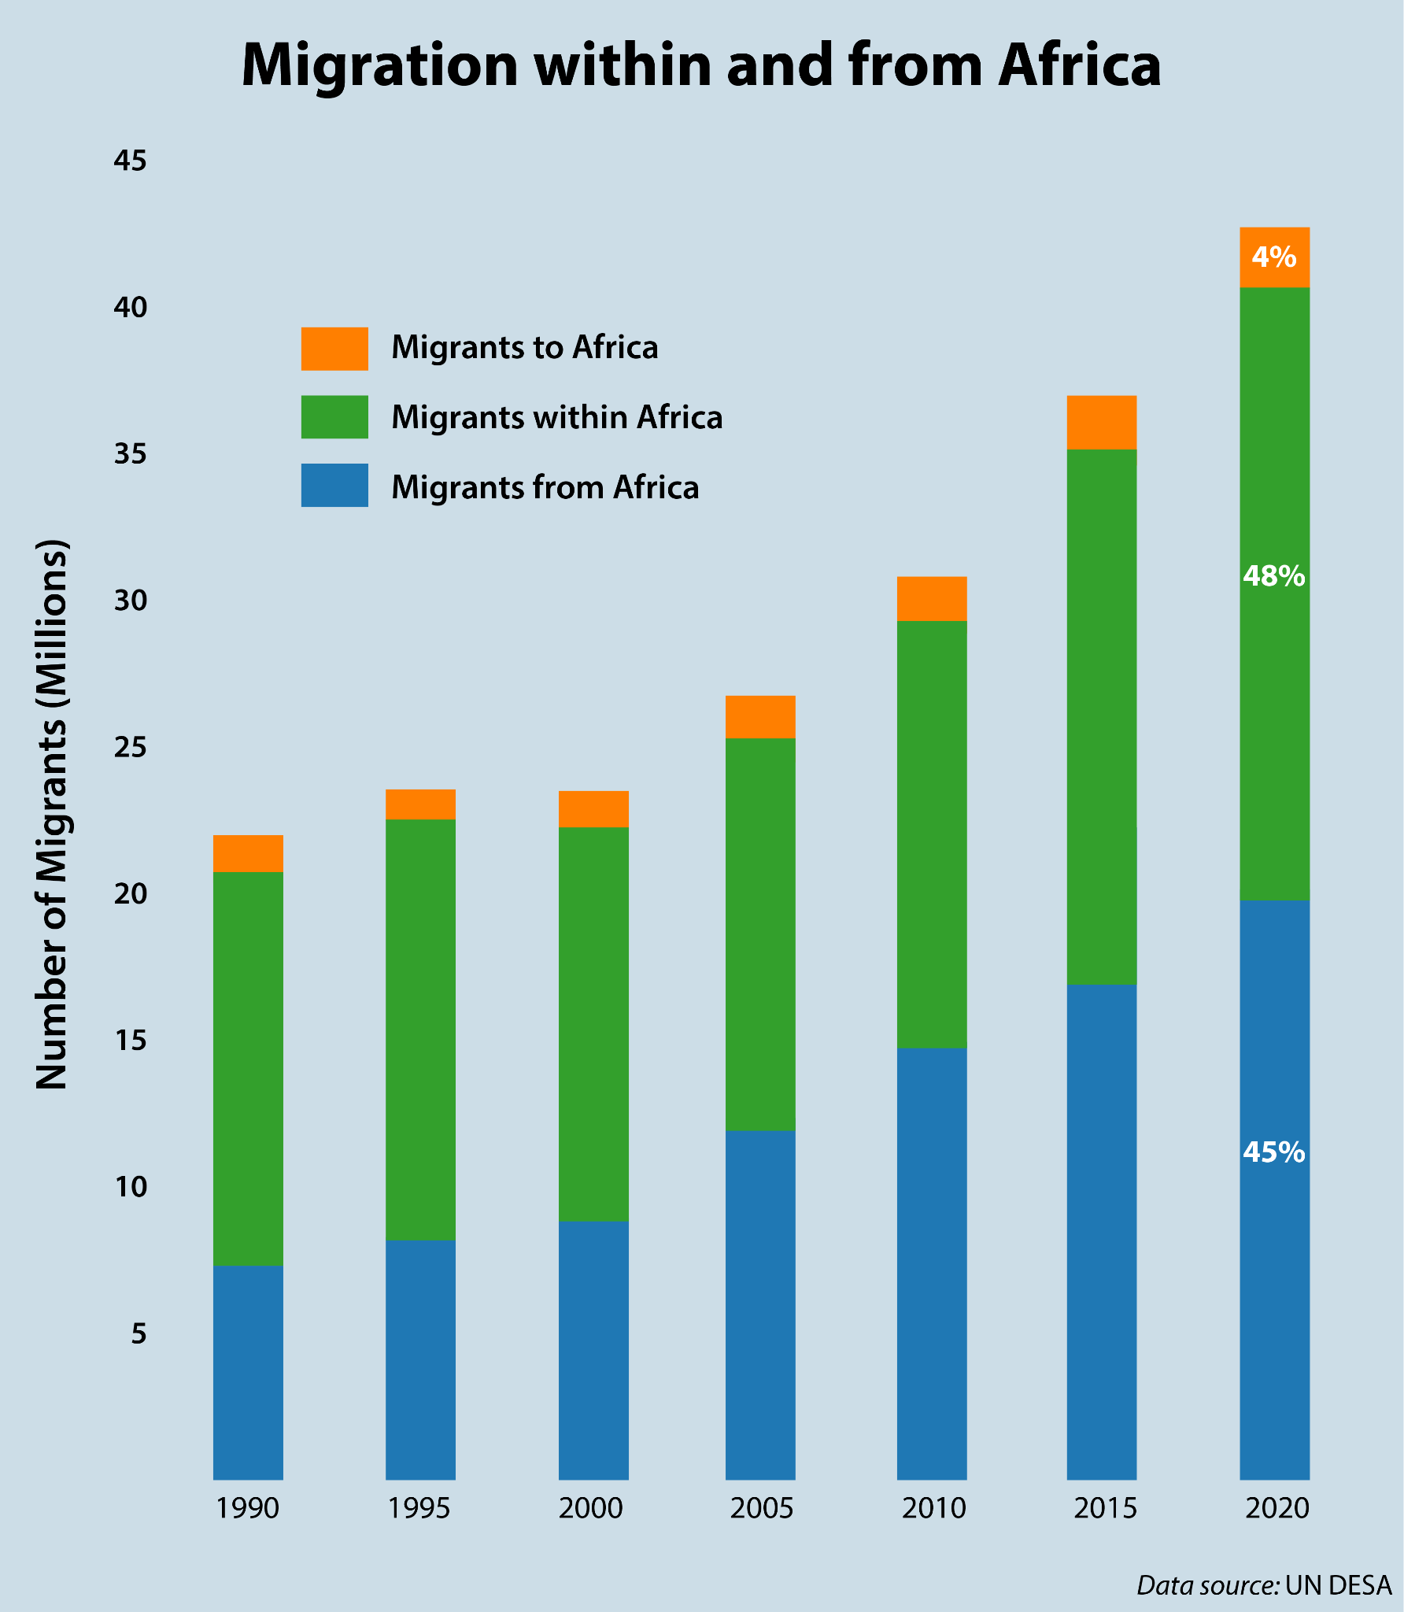

African Center for Strategic Studies. (2021). *Migration within and from Africa.* [Image]. African Center for Strategic Studies. <https://africacenter.org/spotlight/african-migration-trends-to-watch-in-2022/>

**3.3. Previous Resolutions**

Efforts have been undertaken to tackle the challenge of cross-border irregular migration from West Africa to the Maghreb and the European Union, yet these endeavors have largely fallen short. The intricacies of the issue present a major hurdle, as it is a multifaceted problem without a singular solution that can effectively address all the root causes of irregular migration (de Haas, 2008).

A significant challenge lies in the absence of a unanimous consensus on how to approach the matter. Diverging opinions among nations result in a spectrum of approaches, ranging from more stringent and restrictive measures to more compassionate and humane strategies (de Haas, 2008).

Several prior initiatives have been implemented to confront the issue of cross-border irregular migration from West Africa to the Maghreb and the European Union. These include the bolstering of border security, which has been a prevalent response but criticized for its ineffectiveness and the human rights abuses it can lead to. Development assistance has also been utilized to target the root causes like poverty and lack of economic opportunities, but its long-term nature raises questions regarding short-term effectiveness in reducing irregular migration. Readmission agreements between countries, allowing for the return of migrants who have entered a country illegally, have also been criticized for resulting in human rights violations. Furthermore, some countries have established legal migration pathways to provide more opportunities for people to migrate legally, although these pathways are often limited and difficult to access (de Haas, 2008).

It is crucial to acknowledge that none of these resolutions have proven wholly successful in adequately addressing the challenge of cross-border irregular migration from West Africa to the Maghreb and the European Union. What is imperative is a more comprehensive approach, one that delves into the root causes of migration, establishes safe and legal migration pathways, and prioritizes the protection of migrants' rights.

However, it has not proven sufficient to address the fundamental causes of migration, such as poverty and lack of economic opportunities. Readmission agreements have faced criticism for resulting in human rights abuses. For instance, some migrants have been repatriated to countries where they confront persecution or violence. Legal migration pathways are often constrained and arduous to access. Notably, initiatives like the EU Blue Card are exclusively available to highly skilled workers, while the EU Seasonal Workers Directive allows for a limited number of seasonal workers to be employed in the European Union (*Migration Flows on the Western Routes*, 2023).

A more inclusive and comprehensive approach is indispensable to effectively address the predicament of cross-border irregular migration from West Africa to the Maghreb and the European Union. This approach must prioritize tackling the underlying causes of migration, establishing safe and accessible legal migration pathways, and safeguarding the rights of migrants.

**3.4. International Response**

The global response to irregular migration from West Africa to the Maghreb and the European Union has been varied. Certain nations have adopted stricter measures, whereas others have leaned towards a more compassionate approach.

At the forefront of the international response, the European Union has actively engaged in addressing irregular migration from West Africa. The EU has allocated funds and conducted training programs in North African countries to enhance border security. Moreover, readmission agreements have been established between the EU and several countries like Morocco, Tunisia, and Libya, permitting the return of migrants who entered the EU unlawfully (*Migration Flows on the Western Routes*, 2023).

The EU has extended development aid to West Africa to tackle the fundamental causes of irregular migration. The focus of this aid encompasses poverty alleviation, economic expansion, and job generation. However, criticisms have been directed at the EU's reaction for being overly stringent and resulting in violations of human rights, such as the repatriation of migrants to countries where they face persecution or violence (*Migration Flows on the Western Routes*, 2023).

The United Nations has also played a crucial role in responding to irregular migration from West Africa on the international stage. Advocating for a more humane and comprehensive approach, the UN emphasizes addressing the root causes of migration, establishing secure and lawful migration routes, and safeguarding migrants' rights. Additionally, the UN has offered financial aid and technical support to both West African and Maghreb countries to bolster effective migration management (de Haas, 2008b).

International bodies like the International Organization for Migration (IOM) and the United Nations High Commissioner for Refugees (UNHCR) have further contributed to the global response. They have provided essential humanitarian assistance to migrants in distress and advocated for the rights of migrants (de Haas, 2008b).

The international response to cross-border irregular migration from West Africa to the Maghreb and the European Union has varied widely. Different nations have adopted diverse stances, necessitating a comprehensive approach that addresses the root causes of migration, establishes secure and legal migration routes, and upholds the rights of migrants (de Haas, 2008b).

**3.5. Useful Sources**

* International Organization for Migration. (2008). *Irregular Migration from West Africa to the Maghreb and the European Union.* IOM Publications.

https://publications.iom.int/system/files/pdf/mrs-32_en.pdf

* United Nations. (2017, December 15). *States prepare global compact for safe, orderly and regular migration* [Video]. YouTube. https://youtu.be/dNRoDxhFCKA?si=xiotZgp2W4KC24x2
* United Nations. (2023). *International migration | United Nations*. the United Nations. https://www.un.org/en/global-issues/migration
* Haas, H. d. (2009, June 23). *3.8. Irregular Migration from WA through the Maghreb to the EU (Regional Conference on Refugee Protection and International Migration in West Africa)*. UNHCR. https://www.unhcr.org/media/3-8-irregular-migration-wa-through-maghreb-eu-regional-conference-refugee-protection-and
* TRT World. (2021, May 8). *Africa Matters: African Migration to Europe* [Video. YouTube. https://www.youtube.com/watch?v=u1J9vH6QZEs

**3.6. Expectations for the debate**

During the debate, it is expected for the delegates to be able to understand and

impersonate their delegation’s position. Additionally, it is anticipated that delegates will be able to come up with different solutions to regulate irregular migration to Maghreb and the European Union, allowing new legal systems to be created in order to tackle the situation.

Besides, full commitment is expected; previous research on the topic, for the delegates to master their position and propose new alternatives to help the flow of the debate and find ways in which the authorities can address the issue, keeping in mind the UDHR (Universal Declaration of Human Rights). And most importantly, gain confidence throughout the debate, and take the sessions as an opportunity to learn, enjoy, and interact with new people.

Lately, it goes without saying that you can count on the Chair for any doubts or inquiries you may have, and please remember that we will accompany you and guide you throughout the whole process.

Without further ado, we look for a progressive debate and wish you all the best luck.

1. **QARMAS**
2. According to your delegation, what legislative actions need to be taken to regulate cross-border migration between Africa and Europe?
3. How has your delegation responded in previous situations like this one?
4. What is the main cause of migration in your country?
5. Do people often immigrate or emigrate to your country? If so, what are the statistics of this migration flow?
6. In what conditions are migrants received in your country? How can your country offer better living conditions for migrants?
7. Has your delegation reached out to other delegations in order come up with solutions to address the issue?

**References**

De Haas, H. (2008a). *Irregular Migration from West Africa to the Maghreb and the European Union.* IOM Publications.

https://publications.iom.int/system/files/pdf/mrs-32_en.pdf

De Haas, H. (2008b). The Myth of Invasion: The Inconvenient Realities of African Migration to Europe. *Third World Quarterly*, *29*(7), 1305–1322. http://www.jstor.org/stable/20455111

*Migration flows on the Western routes*. (2023, August 30). Council of the European Union. https://www.consilium.europa.eu/en/policies/eu-migration-policy/western-routes/

Africa Center for Strategic Studies. (2021, December 17). *African Migration Trends to Watch in 2022 – Africa Center for Strategic Studies*. Africa Center for Strategic Studies. https://africacenter.org/spotlight/african-migration-trends-to-watch-in-2022/

TRT World. (2021, May 8). *Africa Matters: African Migration to Europe*. YouTube. https://www.youtube.com/watch?v=u1J9vH6QZEs

Haas, H. d. (2009, June 23). *3.8. Irregular Migration from WA through the Maghreb to the EU (Regional Conference on Refugee Protection and International Migration in West Africa)*. UNHCR. https://www.unhcr.org/media/3-8-irregular-migration-wa-through-maghreb-eu-regional-conference-refugee-protection-and

International Organization for Migration. (2008). *Irregular Migration from West Africa to the Maghreb and the European Union:*. IOM Publications.

https://publications.iom.int/system/files/pdf/mrs-32_en.pdf

Permanent Representations. (2023). *UNODC | PR UN, Vienna*. The Netherlands at International Organisations. https://www.permanentrepresentations.nl/permanent-representations/pr-un-vienna/the-mission/departments/unodc

United Nations. (2017, December 15). *States prepare global compact for safe, orderly and regular migration*. YouTube. https://youtu.be/dNRoDxhFCKA?si=xiotZgp2W4KC24x2

United Nations. (2023). *International migration | United Nations*. the United Nations. https://www.un.org/en/global-issues/migration

United Nations Office on Drugs and Crimes. (2023). *UNODC and Human Rights - Preventing and Countering Organized Crime*. UNODC. https://www.unodc.org/unodc/es/humanrights/areas/organized-crime.html

UNODC. (2023). *About Us*. UNODC. https://www.unodc.org/southernafrica/en/sa/about.html