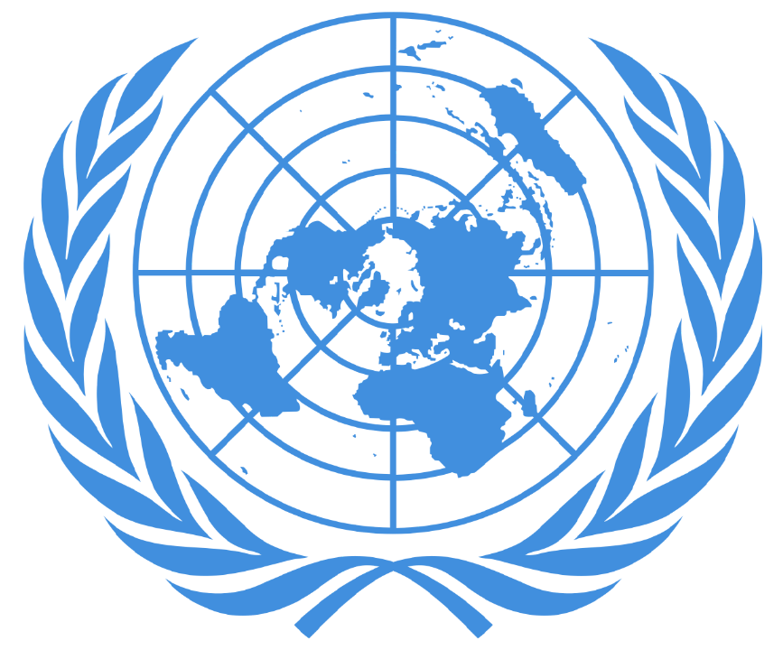

Internal Model 2020
WHO
Russian Federation

TABLE OF CONTENTS
1. General information
1.1 Flag
1.2 Official name
1.3 Limits
1.4 Surface
1.5 Population
1.6 Capital
1.7 Main cities
1.8 Language
1.9 Ethnic groups
1.10 Money currency
1.11 Weather
1.12 Religion
1.15 Economic indicators
1.16 Agriculture
1.17 Government
1.18 Political parties
1.19 Location
2. Topic: Mental health deterioration and the increase in suicide rates in young adults and teenagers due to the Covid-19 pandemic
3. Speech
4. Bibliography

1. GENERAL INFORMATION
1.1 Flag
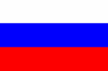
1.2 Official name and symbols
The official name is the Russian Federation, or in russian, Rossiyskaya Federatsiya. It was founded in the century XII. This country is also called the Russian Empire and Russian Soviet Federative Socialist Republic.
The representative symbols of the Russian Federation are: the emblem, which consists of a red surface with a golden Two-Headed Eagle, which has on its chest the Moscow shield with an image of St. George beating the demons, and holds on his right claw an orb and on the left a scepter; the flag, which is used since the 17th century, but was adopted in its present form on 11 December 1993, consisting of a canvas of three horizontal stripes, white on top, blue in the middle, and red at the bottom; and finally, the anthem, being the music by Aleksandr Aleksandrov, and Lyrics by Sergei Mikhalkov.
1.3 Location/geography
The Russian Federation is the largest country in the world in terms of area, it being 17,098,242 km2. This country is located in Eastern Europe and North Asia, bordering the Arctic Ocean, extending from Europe to the North Pacific Ocean. Russia limits Azerbaijan, Belarus, China, Estonia, Finland, Georgia, Kazakhstan, North Korea, Latvia, Lithuania, Mongolia, Norway, Poland, and Ukraine. The Russian Federation has a wide plain terrain with low hills, vast coniferous forest and tundra, highlands and mountains. Its capital is Moscow, located in the western part it is the most populous federal entity in the country. Much of the country lacks proper soils and climates (either too cold or too dry) for agriculture.
1.5 Population
The total population of the Russian Federation is approximately 141’722,205 as of July 2020, and its inhabitants are called Russians. This country has a growth rate of -0.08% (established 2017); a birth rate of 11 births/1,000 population (established 2017), and a mortality rate of 13.5 deaths/1,000 population (established 2017). Life Expectancy for people in Russia is of 71 years.
1.6 Capital
The capital of The Russian Federation is Moscow, 12.41 million (2018). Moscow is the largest, most populous, and the capital city of Russia. It is located in the western part of the country and lies entirely on the European continent. Moscow is the world's 14th largest metro by area and 11th by population. Moscow is the seat of the government; it houses the Kremlin and the two chambers of parliament.
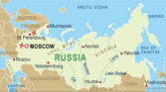
1.7 Main cities
- Moscow (10,381,222)
- St Petersburg (5,028,000)
- Novosibirsk (1,419,007)
- Ekaterinburg (1,349,772)
- Nizhny Novgorod (1,284,164)
1.8 Language
The official language of the Russian Federation is Russian, which is spoken by
85.7% of the population (established 2010). After Russian, languages speaking in this country are Tartar (3.2%), Chechen (1%), Dolgang (5.3%), German (1.5%), and others (10.3%), (established 2010).
1.9 Ethnic groups
80.9% of the population is Russian; 3.9% the population is Tatar; 1.4% of the population is Ukrainian; 1.2% of the population is population Bashkir; 1.1% of the population is Chuvash; 1% of the population is Chechen; 0.9% is Armenian; and 10.2% of the population is another.
1.10 Money currency
Russian Ruble
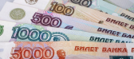
1.11 Climate
The climate of the Russian Federation extends from the grasslands located in the south of the country, to the humid continental in a large part of Russia on the side from Europe; Sub-Arctic in Siberia to tundra climate in the north polar; winters can vary along the Black Sea coast to Siberia; and summers can also vary from grasslands to fresh ones along the coast Arctic. The Russian Federation has warm to hot dry summers and very cold winters with temperatures of -30°C and lower; sometimes heavy snowfall. Strong easterly winds, called Buran can occur, bringing freezing cold temperatures and snowstorms. Climate varies from region to region.
1.12 Religion
The Russian Federation has large populations of non-believers, practitioners and believers, which is a legacy of the Soviet government. In the Russian Federation the following religions are present: Russian Orthodox Christianity (70-73% of the population); Islamism (10-15% of the population), other Christians (2% of the population); non-affiliated beliefs (15%); and other faiths (1%).
1.13 Economic indicators
Since the collapse of the Soviet Union, the Russian Federation has gone through important changes such as moving from a centrally planned economy to a more market-based system. Some economic reforms in 1990 privatized a large part of the industry, with exceptions in transport-related sectors, banking, defense, and energy. In addition, the protection of property is weak, and the state interferes with the free operation of the private sector. Russia is the leading producer of natural gas and oil in the world, and is an important exporter of metals. The main agricultural products are: grain, milk, sugar beets, beef, sunflower seeds, vegetables, and fruits. The industry, with a growth rate of 1.1% (established 2017), includes all types of mining and extractive industries; numerous forms of construction machinery; defence Industries; shipbuilding; transport equipment (road / rail); communications equipment; generation and electrical transmission; different scientific and medical instruments; and articles consumption. This country has export partners to the Netherlands (10.5%), China (10.3%), Germany (7.8%), Turkey (5%), Italy (4.4%), and Belarus (4.3%)%) (established 2016); and has as import partners to China (21.6%), Germany (11%), United States (6.3%), France (4.8%), Italy (4.4%), and Belarus (4.3%) (established 2016).
1.14 Agriculture
The main crops grown in Russia as measured by area cultivated are wheat, barley, sunflower seeds, oats, potatoes and rye. The largest share of cultivable land is dedicated to wheat, which with 26.6 million hectares in harvested area in 2009 occupied 21.9% of all cultivable land in Russia. Agricultural lands occupy 13 % of the territory of Russia. At the moment the global warming impact on Russian agriculture is currently assessed as favourable. It has already reduced the number of winters threatening crops. In many regions the vegetation period has increased by 5–10 days. The vegetation period for field crops has been lasting longer.
1.15 Government
The Russian Federation is a semi-presidential federation in which the President (Valdimir Putin) is the head of state and the Prime Minister (Mikhail Mishustin) is head of government. The Russian Federation’s legal system consists of the civil law system and judicial review of acts.
The Russian Federal Assembly (parliament) is composed of 616 members and is made up of two houses, the 450-member State Duma (lower house) and the 166-member Federation Council (upper house).
The president retains the power to direct all of Russia’s domestic and foreign policy affairs, and represents the country when abroad. The Russian presidency has been criticised for being too dictatorial in the past. The president appoints the prime minister to chair the government (or cabinet) with approval from the State Duma, though he can dismiss government members and the Duma itself under certain conditions. The prime minister is also responsible for appointing and dismissing justices to office, and is the Supreme Commander-in-Chief of the Armed Forces of the Russian Federation with the
power to declare national or regional states of martial law, and national states of emergency. The Constitutional Court, Supreme Court, Supreme Court of Arbitration sit at the head of the judicial branch of the Russian government; district courts are responsible for criminal trials. The judiciary is overseen by the All-Russian Congress of Judges and its Council of Judges – the Prosecutor General is the head of the Russian judicial system.
1.16 Political parties
- United Russia
- Communist party
- Liberal democratic party of Russia
- A just Russia
- The other Russia
- Rodina
- Civic platform
- Patriots of Russia
- Yábloko

2. TOPIC: Mental health deterioration and the increase in suicide rates in young adults and teenagers due to the Covid-19 pandemic
2.1. History of the topic
Suicide rates and mental health problems throughout history have always been linked to many factors, but one that especially affects them is large, catastrophic events such as natural disasters, plague and economic recessions. It is normal for m
2.2 Country’s position
Suicide has been a significant issue for not only Russia, but most other countries in eastern europe. The suicide rate for the Russian Federation is of 31 out of 100,000 people (estimate from 2016), while the global average is 10.5. While this rate has been steadily declining since at least the year 2000, it follows the trend set by the rest of the world: suicides from young people are increasing. Another thing to note is that male suicide is more prevalent than female suicide by a large margin in Russia; and a large source of disease burden.
When it comes to Covid-19, Russia was able to handle the crisis effectively at first, but then started implementing local quarantine measures to contain outbreaks that were mostly centered around major cities. Nation-wide measures were not as strict, but several “non-working” weeks were declared from march to may, during the first peak of the pandemic in the country. After that, places started slowly reopening and by early june, Moscow’s strict lockdown ended and the country basically called victory despite the still relatively high number of cases. The situation stayed that way, in a moderate, slightly decreasing plateau for several months, until cases began spiking like never before in a second wave in september. This time, the russian government refused to go back into full lockdown despite the surge in cases. This is probably to salvage their economy, but also to protect their citizens from the mental strain that lockdowns cause.
Russia as a whole is a nation that understands that their citizens have mental health needs. The russian government has started to take steps towards providing mental health services that citizens need, especially during the pandemic. For example, Russia accepted and implemented a WHO self-harm monitoring tool across the country with all the adaptations needed to make it work in the country. They’ve also moved towards more instances of tele-therapy, as it not only beneficial during the pandemic, but also in general due to the remoteness of some areas, so not everyone would have access to a mental health professional because of where they live, but with this method, it becomes easier to get to everybody who needs it.
The Russian Federation has been relying on their possible Covid-19 vaccine, Sputnik V, as a means to maintain the country open. They say that the trials are going well and that they are about to start distributing industrially manufactured doses. Because of the vaccine, Russia maintains hope, but also refuses to go into lockdown if necessary. The general rule for russians right now is to take care of themselves, but to maintain their daily activities.
2.3 Possible solutions
- Tele-therapy sessions funded by the national government as a measure of mitigation.
- A good result of the Sputnik V trials, resulting in mass vaccination that eliminates the need to socially distance.
- Continuation of the program proposed by WHO Europe to monitor self harm in the general population
- Integration of mental health education into school curriculum to develop emotional intelligence and decrease taboo from a young age, giving people tools to deal with possible mental health issues in the future.
- Programs of general education so that people can identify when someone close or themselves are dealing with m

5. SPEECH
Good morning honorable members of the chair, delegates and others present. The Russian delegation is profoundly concerned with it’s citizen’s mental health during the ongoing pandemic and is willing to cooperate with the international community to agree on a plan of action that will benefit the well-being of russian nationals..
This delegation identifies that the issue at hand has a clear source: the pandemic, and that while it is impossible to control nature, the response given is what dictates the severity of the effects on both mental and physical health. It is for that reason that this delegation considers that a good management of the pandemic is decisive when it comes to young people’s mental health.
Other methods of mitigating the impact on young minds like accessibility to mental health professionals and monitoring people’s mental state are imperative at this point in time, but in the long run, the focus should be in preventing events such as pandemics from becoming catastrophic to people’s lives.
Thank you.

4. BIBLIOGRAPHY
Russia (n.d). Retrieved from https://www.infoplease.com/world/countries/russia - Russia population 2019 (2019, October 3). Retrieved from http://worldpopulationreview.com/countries/russia-population/
Kripop, V. (2018, July 4). What is the capital of Russia? Retrieved from https://www.worldatlas.com/articles/what-is-the-capital-of-russia.html
Hays, J. (2008). Russian and languages in Russia. Retrieved from http://factsanddetails.com/russia/People_and_Life/sub9_2c/entry-4996.html#
Sawe, B. (2019, July 18). Largest Ethnic Groups In Russia. Retrieved from https://www.worldatlas.com/articles/largest-ethnic-groups-in-russia.html - Russia (n.d). Retrieved from https://www.weatheronline.co.uk/reports/climate/Russia.htm
Johnson, B. (2019, April 17). What Are The Political Parties In Current-day Russia? https://www.thoughtco.com/political-parties-in-russia-3555401
Agriculture And Horticulture in Russia (n.d). Retrieved from https://www.climatechangepost.com/russia/agriculture-and-horticulture/
FAO Agriculture And Trade Policy (n.d). Retrieved from http://www.fao.org/fileadmin/templates/est/meetings/wto_comm/Trade_Policy_Brief_Ru ssia_final.pdf
Shanghai Cooperation Organisation (n.d). Retrieved from https://ccdcoe.org/organisations/sco/

https://www.cia.gov/library/publications/the-world-factbook/geos/rs.html

https://apps.who.int/gho/data/node.main.MHSUICIDE

https://www.who.int/data/gho/data/themes/mental-health#:~:text=Age%2Dstandardized%20suicide%20rates%3A%20There,10.5%20per%20100%20000%20population.

https://www.bbc.com/news/world-europe-54885616

https://www.dailymail.co.uk/news/article-8166833/Moscow-enters-lockdown-stop-spread-coronavirus.html

https://www.straitstimes.com/world/europe/moscows-lockdown-ends-as-coronavirus-cases-in-russia-pass-485000

https://www.consortium-psy.com/jour/article/view/28?locale=en_US#

